Milestone 2 & 3 Progress Documentation
Vertex AI Layout-to-JSON Foundation for Adobe InDesign Workflow
Prepared for: Henry
Prepared by: Jawad
Date: June 6, 2026
Document purpose
This document converts the recent progress update into a step-by-step technical completion record that can be reviewed with the client. It is written to match the Milestone 1 verification style: each step includes objective, current completion status, repository evidence, and screenshot placeholders for review proof.

1. Executive Summary
Since completing the Milestone 1 foundation work, the project has moved into the first functional layout-to-JSON workflow. The current implementation is focused on creating a controlled foundation that can take natural language layout intent, retrieve relevant layout examples, build a prompt context, send the request through Vertex AI/Gemini, return structured JSON, and validate the output against an early schema gate.
The work is still in active development. The current goal is not to claim a production-ready layout engine yet. The goal is to show the first end-to-end foundation, prove the direction, and prepare the validation and handoff pieces that are required for Milestone 3.

2. Progress at a Glance
Workstream | Current status | Repository evidence
Project workspace setup | Completed | Top-level folders for config, docs, raw data, normalized data, schemas, scripts, tests, utils, and outputs.
Raw sample organization | Completed / continuing as new samples arrive | raw_data/ contains JSON files, IDML exports, images, and client notes.
Schema mapping | Foundational version completed; still being expanded | schemas/layout_schema.py and schemas/schema_map.mmd.
Normalized prompt/example library | First version completed | normalized_data/layout_prompt_library.json.
Retrieval flow | First version completed | scripts/retrieve_prompt_examples.py and utils/retrieval_utils.py.
Context builder | Initial version completed | scripts/build_context_pair.py.
Vertex AI/Gemini generation layer | Initial development integration completed | scripts/generate_layout.py and config/service account setup.
Structured output saving | Initial version completed | outputs/generated_layout.json.
Validation gate | Initial Pydantic validation in development | schemas/layout_schema.py and tests/validate_layout_schema.py.
Special cases | Controlled examples in progress | Overflow, two-text-box, image-bleed, and continuation samples in raw_data and normalized_data.
Evaluation output | Initial retrieval evaluation output created | outputs/retrieval_eval_results.csv and tests/evaluate_prompt_examples.py.
Documentation and setup guides | In progress | docs/Milestone 1 Verification.docx and docs/Vertex AI Development Setup Guide From Scratch.docx.

Github Repo Link: https://github.com/jawadengineer12/gcp-vertex-ai
Project root folder structure
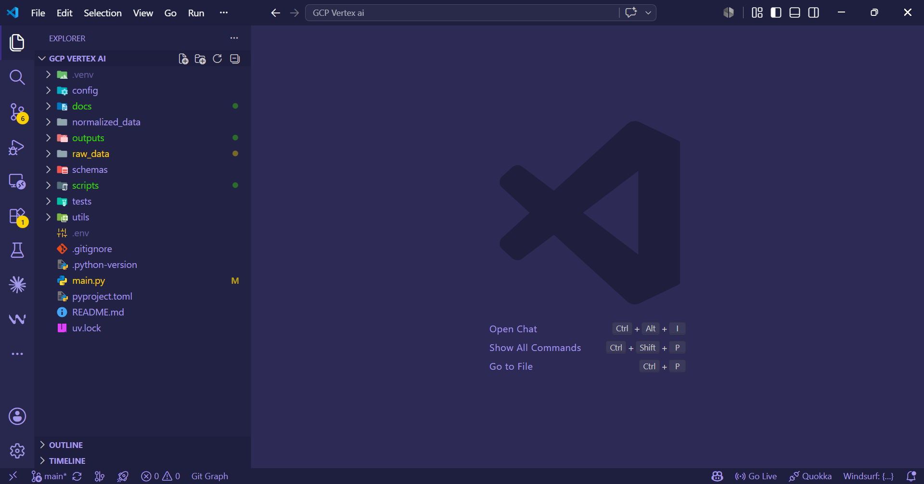

3. Current Repository Structure Reviewed for This Progress Report
The project is currently organized as a Python-based pipeline with separate folders for source data, normalized examples, schema definitions, generation scripts, tests, utilities, and generated outputs.
- config/ - Google Cloud service account configuration for local development access.
- docs/ - Milestone verification and Vertex AI development setup documentation.
- raw_data/ - Original client-provided JSON, IDML files, export folders, images, and descriptions.
- normalized_data/ - Clean prompt/example library used for retrieval and context construction.
- schemas/ - Layout schema and schema map used for structured validation.
- scripts/ - Runnable steps for retrieval, context building, and layout generation.
- tests/ - Validation and evaluation scripts for schema, prompt library, Vertex connection, and retrieval performance.
- utils/ - Shared retrieval logic used by scripts.
- outputs/ - Generated layout JSON and retrieval evaluation results.

4. Step-by-Step Completion Record

Step 1. Project Workspace and Folder Separation
Status: Completed
Objective: Create a maintainable working structure so raw data, normalized examples, schema work, generation scripts, tests, and outputs are not mixed together.
Completed work:
- Created separate folders for raw data, normalized data, schemas, scripts, tests, utilities, documentation, and outputs.
- Kept client-provided data under raw_data/ and generated development outputs under outputs/.
- Separated reusable code under utils/ and runnable pipeline steps under scripts/.
Evidence in repository:
- Top-level project tree: config/, docs/, normalized_data/, outputs/, raw_data/, schemas/, scripts/, tests/, utils/.
- Project entry/config files: main.py, pyproject.toml, uv.lock.
Current next action: Continue keeping any new client samples in raw_data/ first, then normalize them into normalized_data/ only after review.
Workspace organization evidence
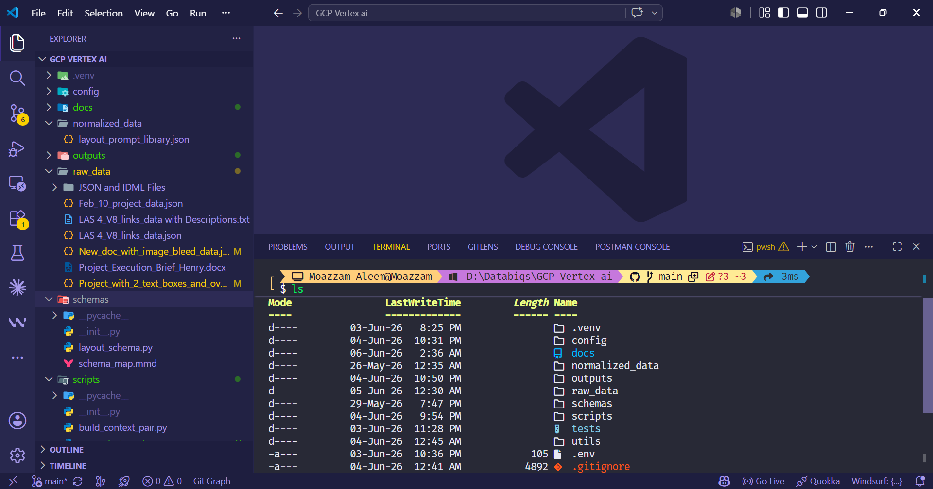

Step 2. Raw Client Sample Intake and Organization
Status: Completed for current samples; ongoing for future samples
Objective: Collect the original client examples in their raw form so they remain traceable before transformation or cleanup.
Completed work:
- Stored original JSON files, IDML files, export folders, linked images, and descriptive notes under raw_data/.
- Separated IDML/export assets under raw_data/JSON and IDML Files/.
- Included special-case samples for image bleed and text overflow behavior.
Evidence in repository:
- raw_data/Feb_10_project_data.json
- raw_data/LAS 4_V8_links_data.json
- raw_data/LAS 4_V8_links_data with Descriptions.txt
- raw_data/New_doc_with_image_bleed_data.json
- raw_data/Project_with_2_text_boxes_and_overflow_data.json
- raw_data/JSON and IDML Files/ with related IDML/export folders and image folders.
Current next action: Confirm with Henry that these are still the approved Phase 1 source samples and identify whether any newer samples should replace or supplement them.

Step 3. Schema Mapping and Layout Field Understanding
Status: Foundational version completed; still being expanded
Objective: Map the JSON structure into expected top-level and nested fields so generated output can be checked before handoff.
Completed work:
- Mapped core blocks including projectInfo, documentSettings, pages, assets, assetType, position, size, content, columns, gutterSize, margins, and textStyle.
- Started separating required structural fields from layout-specific optional fields.
- Created the basis for Pydantic validation so invalid outputs can be caught early.
Evidence in repository:
- schemas/layout_schema.py
- schemas/schema_map.mmd
- tests/validate_layout_schema.py
Current next action: Expand validation rules beyond structural checks into layout-safety checks such as coordinate ranges, page bounds, asset types, and overflow expectations.

Step 4. Normalized Prompt/Example Library
Status: First version completed
Objective: Convert layout descriptions and expected JSON into a reusable prompt/example library that can be retrieved when a new user instruction is received.
Completed work:
- Created a normalized layout prompt library from client-provided page descriptions and expected JSON structures.
- Structured examples around natural_language_intent and expected_layout_json so the generation layer can receive relevant context.
- Prepared the library as the first RAG-like context source for layout generation.
Evidence in repository:
- normalized_data/layout_prompt_library.json
- tests/validate_prompt_library.py
Current next action: Continue adding special cases and richer page-role descriptions to improve retrieval and generation quality.
Normalized prompt library evidence
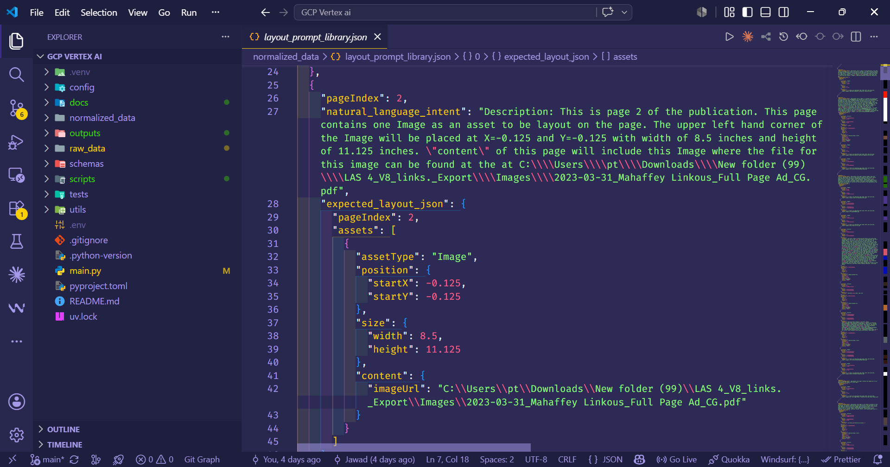

Step 5. Prompt Example Retrieval Flow
Status: First version completed
Objective: Build a retrieval step that finds relevant layout examples for a new user prompt before sending the request to Gemini.
Completed work:
- Implemented a retrieval script that accepts a user layout prompt from the command line.
- Loaded the normalized prompt/example library.
- Returned the top matching examples to be used as generation context.
- Kept retrieval modular so it can later be upgraded from rule/keyword matching to vector search if needed.
Evidence in repository:
- scripts/retrieve_prompt_examples.py
- utils/retrieval_utils.py
- outputs/retrieval_eval_results.csv
Current next action: Review retrieval quality with Henry using a few real layout prompts and decide whether to keep lightweight matching for Phase 1 or add vector embeddings next.
Retrieval terminal evidence
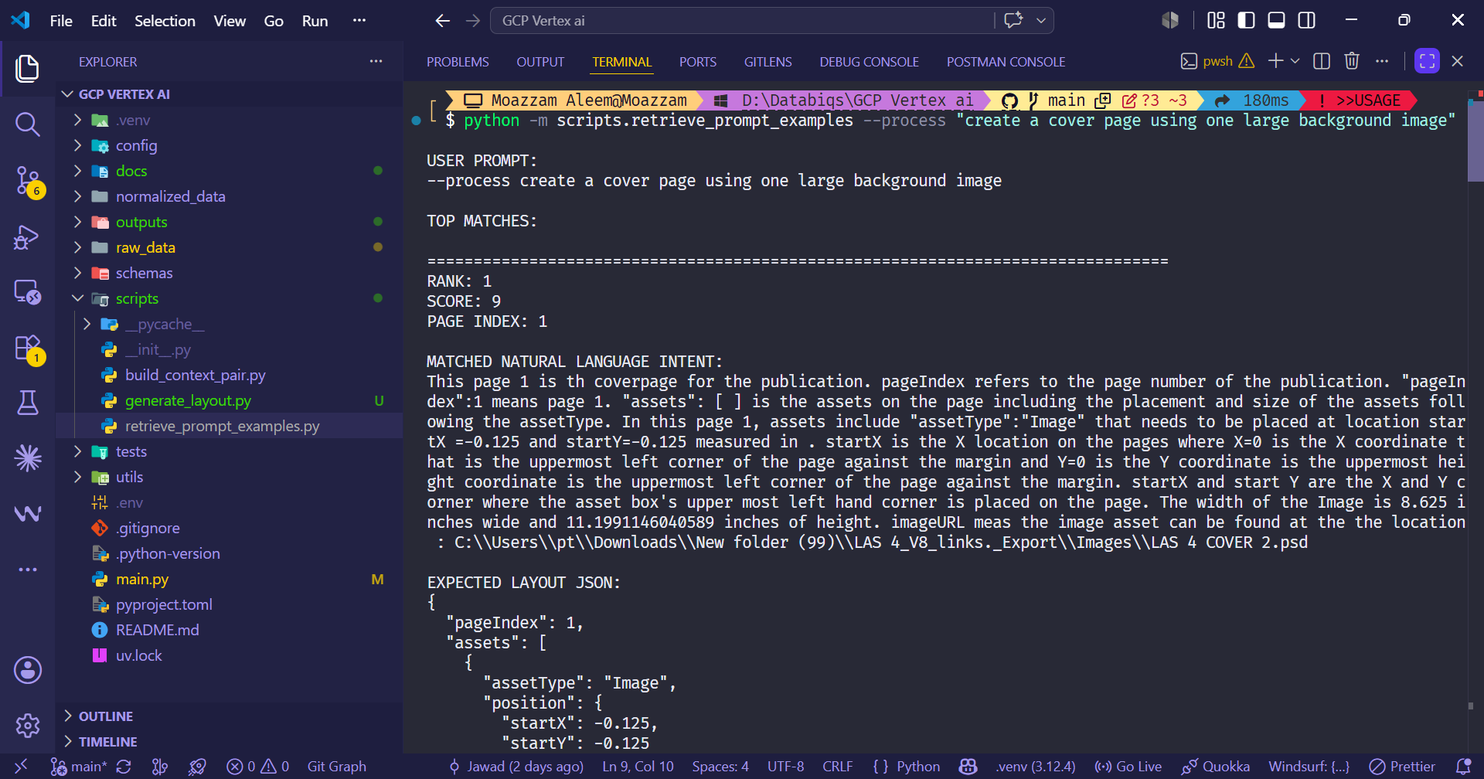

Step 6. Context Pair Builder
Status: Initial version completed
Objective: Create the bridge between retrieval and generation by packaging the user instruction with the matched layout examples.
Completed work:
- Added a context-building step that prepares matched examples for the generation layer.
- Kept the context construction separate from retrieval and generation to make the pipeline easier to test.
- Prepared this module so future prompt formatting rules can be changed without rewriting retrieval logic.
Evidence in repository:
- scripts/build_context_pair.py
- scripts/generate_layout.py

Step 7. Vertex AI/Gemini Generation Layer
Status: Initial development integration completed
Objective: Connect the structured prompt context to Vertex AI/Gemini so the system can generate schema-aligned JSON from a user layout prompt.
Completed work:
- Started integrating the Vertex AI/Gemini generation layer into the Python pipeline.
- Prepared local development access through service account configuration.
- Built the first generation script that sends user prompt plus matched examples to the model and receives structured JSON back.
Evidence in repository:
- scripts/generate_layout.py
- config/gcp-sa-key.json
- docs/Vertex AI Development Setup Guide From Scratch.docx
- tests/test_vertex_connection.py
Current next action: Confirm final client-side Vertex/Gemini enterprise setup, IAM access, and whether the service account configuration should be moved into the client-controlled environment.
Vertex/Gemini generation evidence
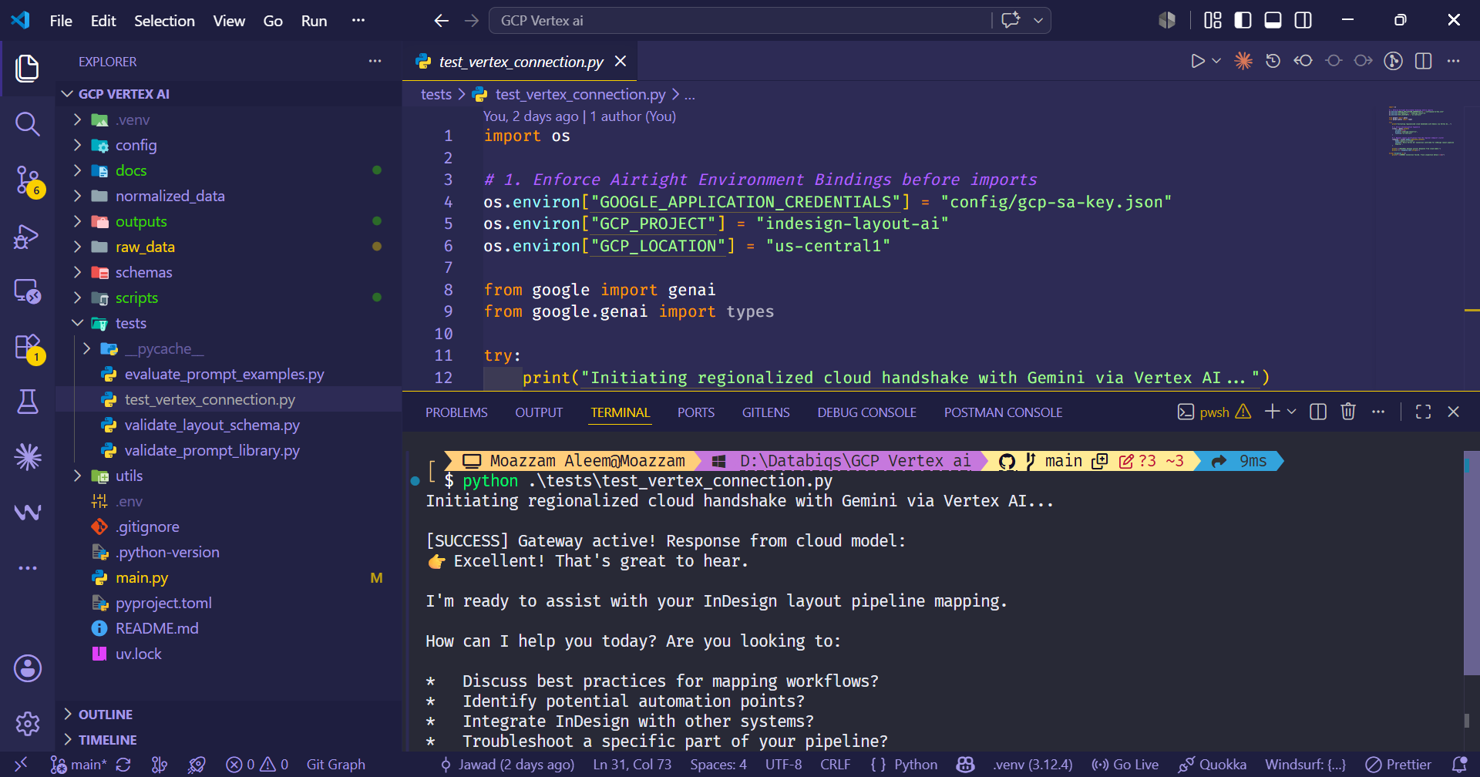

Step 8. Structured JSON Output Generation and Saving
Status: Initial version completed
Objective: Save model output into a predictable JSON output file for review, validation, and downstream handoff testing.
Completed work:
- Configured generation output to be saved under outputs/.
- Created generated_layout.json as the current output target.
- Separated generated artifacts from raw samples so review and debugging remain clean.
Evidence in repository:
- outputs/generated_layout.json
- scripts/generate_layout.py
Current next action: Compare generated_layout.json against known expected outputs and refine prompt rules where the model drifts from schema or layout expectations.
Generated output evidence
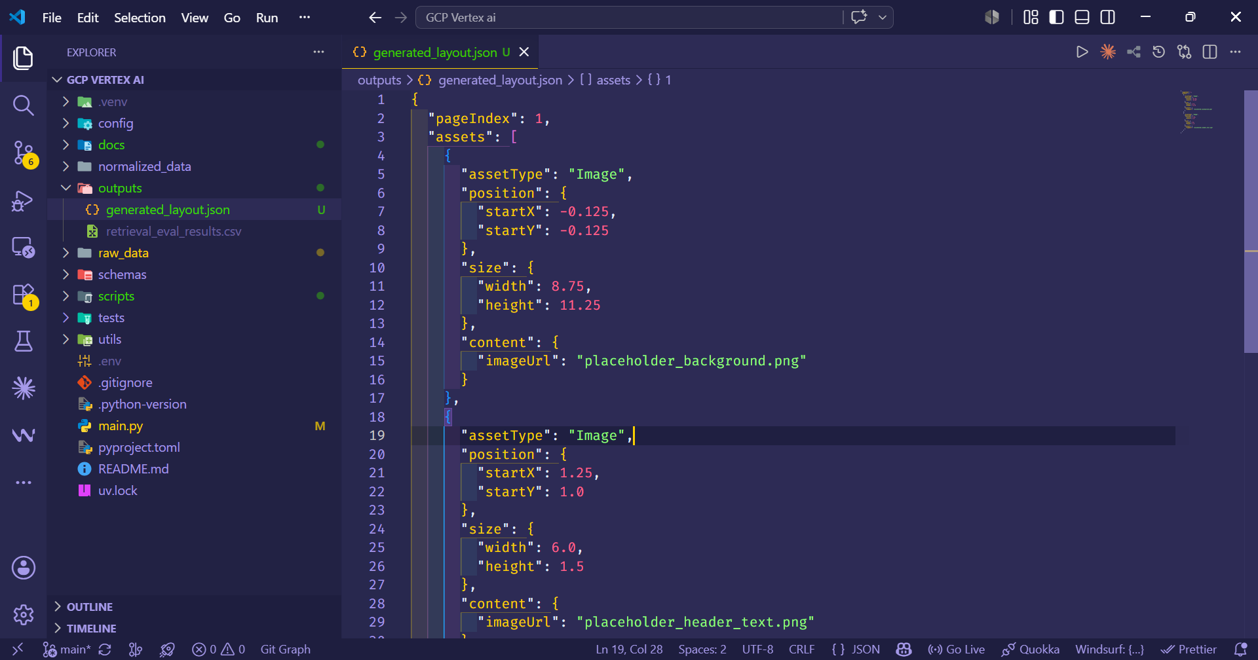

Step 9. Pydantic Validation Gate
Status: Initial version in development
Objective: Add a validation layer so malformed model outputs do not flow directly into the downstream converter.
Completed work:
- Created an initial Pydantic-based layout schema gate.
- Started validating generated outputs against expected structure.
- Began catching early issues such as invalid asset types, missing fields, and incorrect structural shapes.
Evidence in repository:
- schemas/layout_schema.py
- tests/validate_layout_schema.py
- outputs/generated_layout.json
Current next action: Expand validation from schema-only checks to layout-specific checks including coordinates, page bounds, text overflow expectations, image bleed, and asset reference consistency.

Step 10. Special Case Incorporation
Status: In progress
Objective: Turn the client-important layout edge cases into controlled examples and validation tests so the system learns and checks behavior intentionally.
Completed work:
- Identified the key special cases: two text boxes on one page with overflow continuation, image bleed across adjacent pages, image overlay text, and page-to-page layout continuation.
- Stored special-case JSON and related assets in raw_data/.
- Started preparing these examples for normalized prompt-library use and validation test coverage.
Evidence in repository:
- raw_data/New_doc_with_image_bleed_data.json
- raw_data/Project_with_2_text_boxes_and_overflow_data.json
- normalized_data/layout_prompt_library.json
- tests/validate_layout_schema.py

Step 11. Retrieval Evaluation Output
Status: Initial version created
Objective: Create a simple measurable way to review whether the retrieval layer is selecting relevant examples for a given prompt.
Completed work:
- Added an evaluation script for prompt/example retrieval.
- Saved initial retrieval evaluation results to CSV.
- Prepared this output so future improvements can be compared instead of judged only by manual inspection.
Evidence in repository:
- tests/evaluate_prompt_examples.py
- outputs/retrieval_eval_results.csv
Current next action: Use additional real prompts from Henry to evaluate retrieval quality and identify gaps in the prompt/example library.
Retrieval evaluation evidence
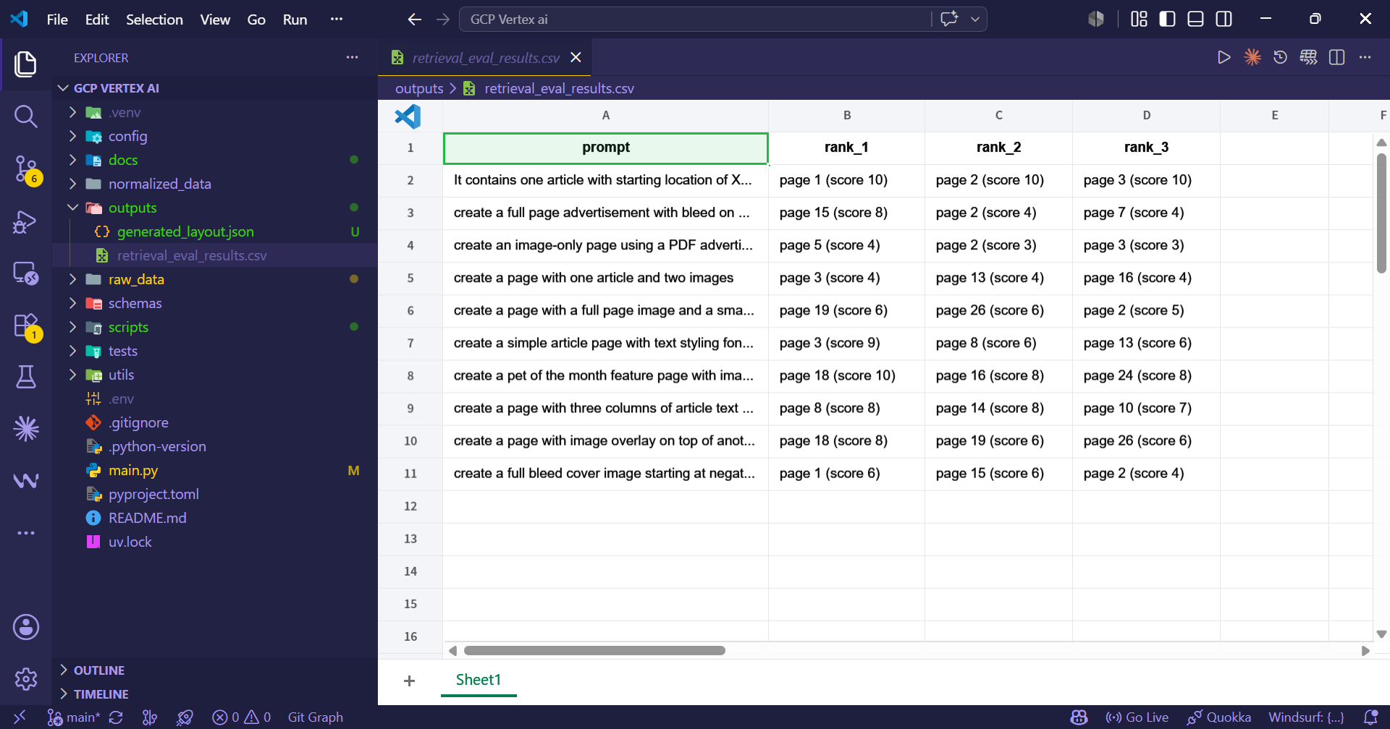

Step 12. Documentation and Handoff Preparation
Status: In progress
Objective: Maintain documentation so the workflow can be reviewed by Henry and continued by another developer without relying on chat history.
Completed work:
- Maintained documentation folder for setup and milestone verification.
- Prepared this step-by-step progress document for client review.
- Structured evidence around repository files, scripts, outputs, and screenshot placeholders.
Evidence in repository:
- docs/Milestone 1 Verification.docx
- docs/Vertex AI Development Setup Guide From Scratch.docx
- This document: Milestone 2 & 3 Progress Documentation
Current next action: After the review call, update this document with actual screenshots, final decisions, and any changes requested by Henry.
Documentation evidence
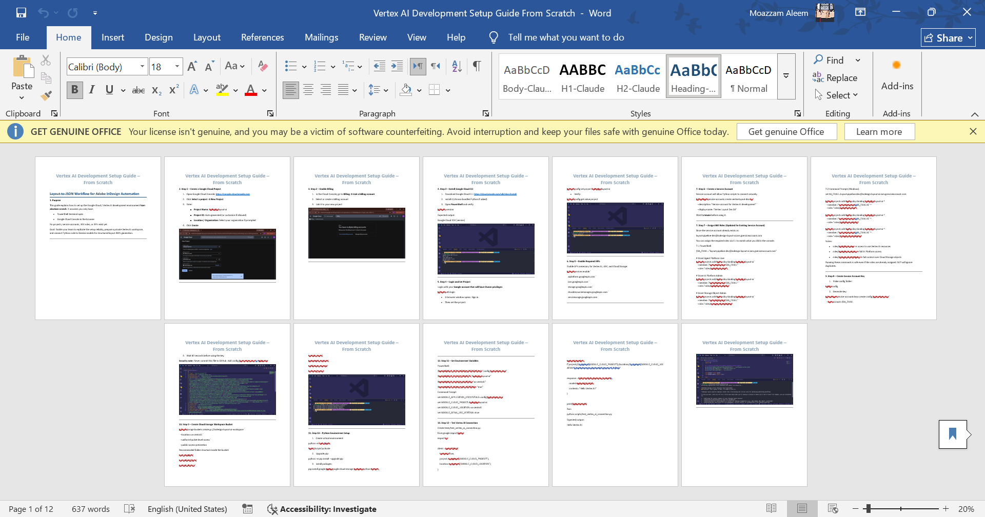

5. Current Technical Pipeline
The current pipeline can be reviewed as the following sequence:
- User provides a natural language layout prompt.
- The retrieval script searches the normalized prompt/example library.
- The context builder combines the user prompt with the best matched examples.
- The generation script sends the combined context to Vertex AI/Gemini.
- Gemini returns a structured JSON layout response.
- The generated JSON is saved under outputs/generated_layout.json.
- The validation layer checks whether the output follows the expected schema and catches early structural problems.

6. Why Milestone 2 and Milestone 3 Are Being Delivered Together
Milestone 2 and Milestone 3 are tightly connected in the current implementation. Generation cannot be meaningfully reviewed without validation, and validation cannot be finalized without testing against generation outputs and special cases. Combining these workstreams produces a more useful review package than separating them artificially.
Module | Original milestone | Reason for overlap
Generation workflow | Milestone 2 | Needs validation and documentation from Milestone 3 to be useful for review.
Special case handling | Milestone 2 | Also becomes validation test coverage in Milestone 3.
Pydantic/schema validation | Milestone 3 | Requires generated outputs from Milestone 2 to test meaningfully.
Documentation and handoff | Milestone 3 | Should document the real working generation path, not just static setup.
Client review package | Both | A combined package lets Henry review the workflow, outputs, validation, and next steps together.

8. Current Known Gaps and Development Watch Items
- The current output is an early workflow output, not final production-ready JSON.
- The Pydantic validation gate is still being expanded beyond basic schema structure.
- Retrieval currently uses the first implementation approach and can be upgraded to vector search later if retrieval quality requires it.
- Special-case behavior needs client confirmation so rules for overflow, continuation, and image bleed are implemented exactly as expected.
- Live enterprise deployment should be confirmed inside the client-controlled GCP / Vertex AI environment before production data is used.

